Test Case: tc005_SPX_Dev5_Crear_Requisicion_Spot_Con_FAD_Tipo_Cobro_Project
Step 1 - Enter username and password and click to button Enter: Credentials Entered
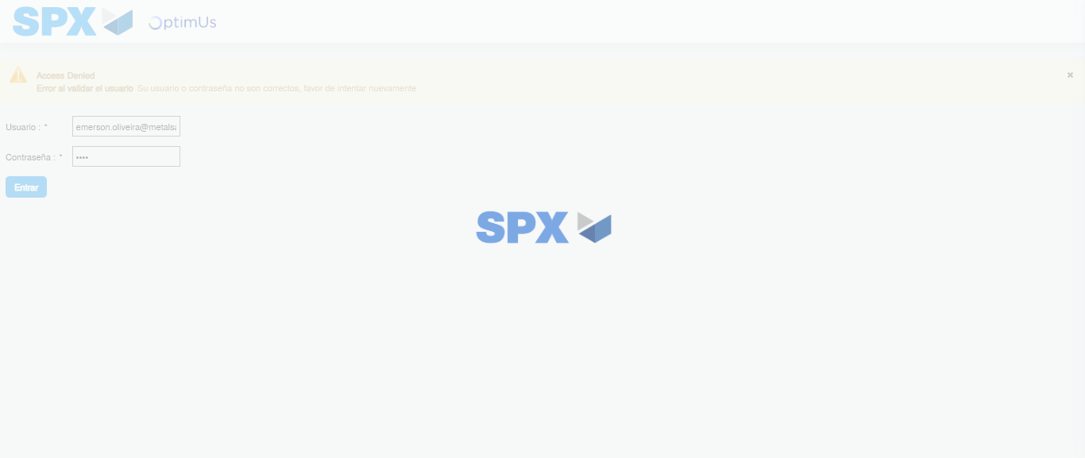Image file-name: QC_Testing-tc005_SPX_Dev5_Crear_Requisicion_Spot_Con_FAD_Tipo_Cobro_Project-1785975939450

Step 2 - Select to UEN and Access to Spot Buy Requisitions : UEN Correctly selected and Correct access
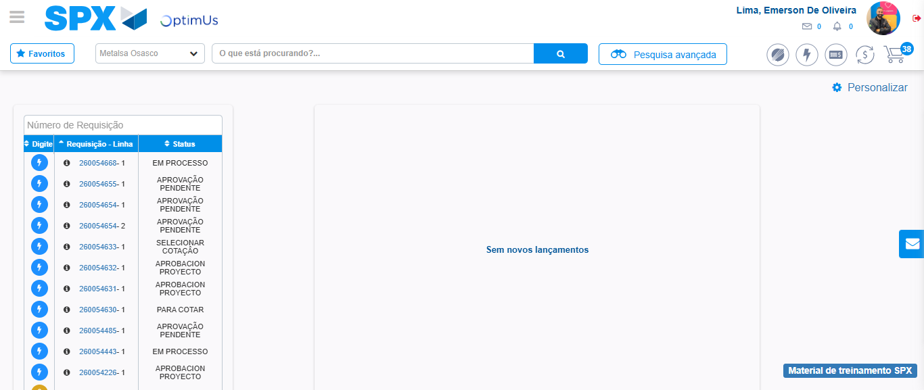Image file-name: QC_Testing-tc005_SPX_Dev5_Crear_Requisicion_Spot_Con_FAD_Tipo_Cobro_Project-1785975964889

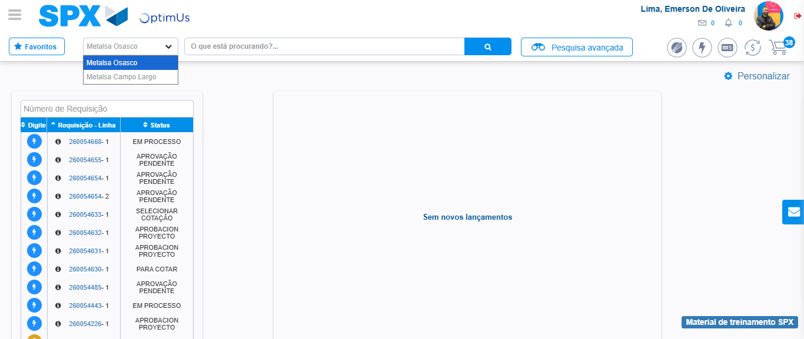Image file-name: QC_Testing-tc005_SPX_Dev5_Crear_Requisicion_Spot_Con_FAD_Tipo_Cobro_Project-1785975967428

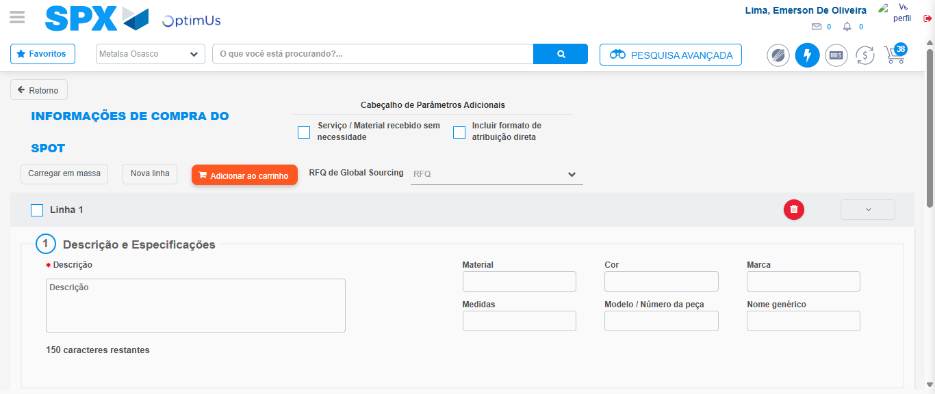Image file-name: QC_Testing-tc005_SPX_Dev5_Crear_Requisicion_Spot_Con_FAD_Tipo_Cobro_Project-1785975972444

Step 3 - Add FAD to Requisition: FAD Successfully Added
Image file-name: QC_Testing-tc005_SPX_Dev5_Crear_Requisicion_Spot_Con_FAD_Tipo_Cobro_Project-1785975972672

Image file-name: QC_Testing-tc005_SPX_Dev5_Crear_Requisicion_Spot_Con_FAD_Tipo_Cobro_Project-1785975972836

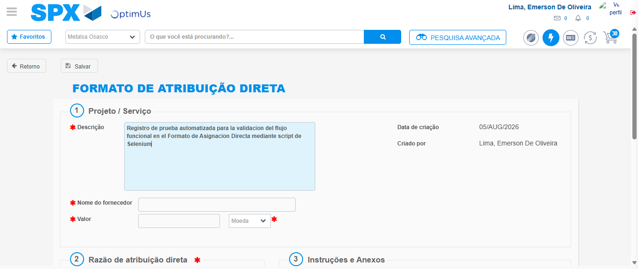Image file-name: QC_Testing-tc005_SPX_Dev5_Crear_Requisicion_Spot_Con_FAD_Tipo_Cobro_Project-1785975975653

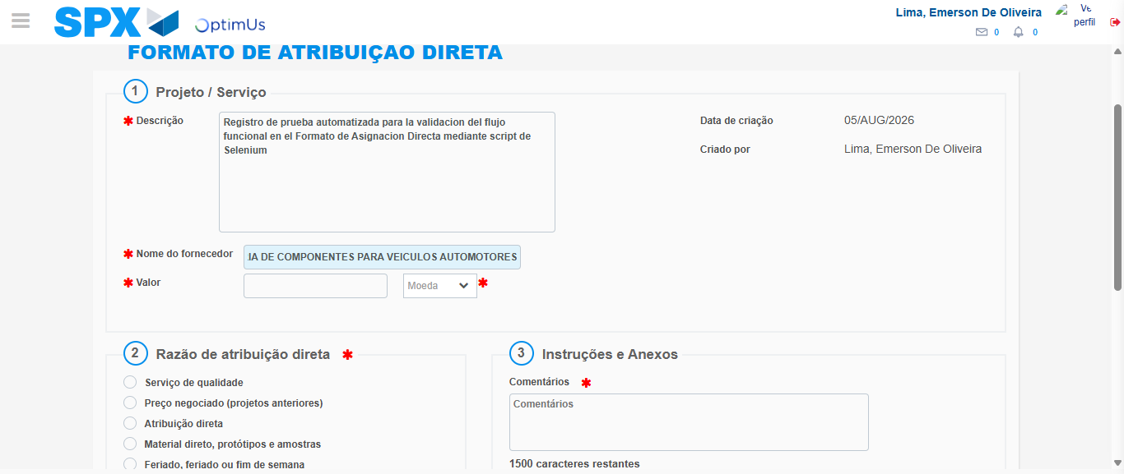Image file-name: QC_Testing-tc005_SPX_Dev5_Crear_Requisicion_Spot_Con_FAD_Tipo_Cobro_Project-1785975985244

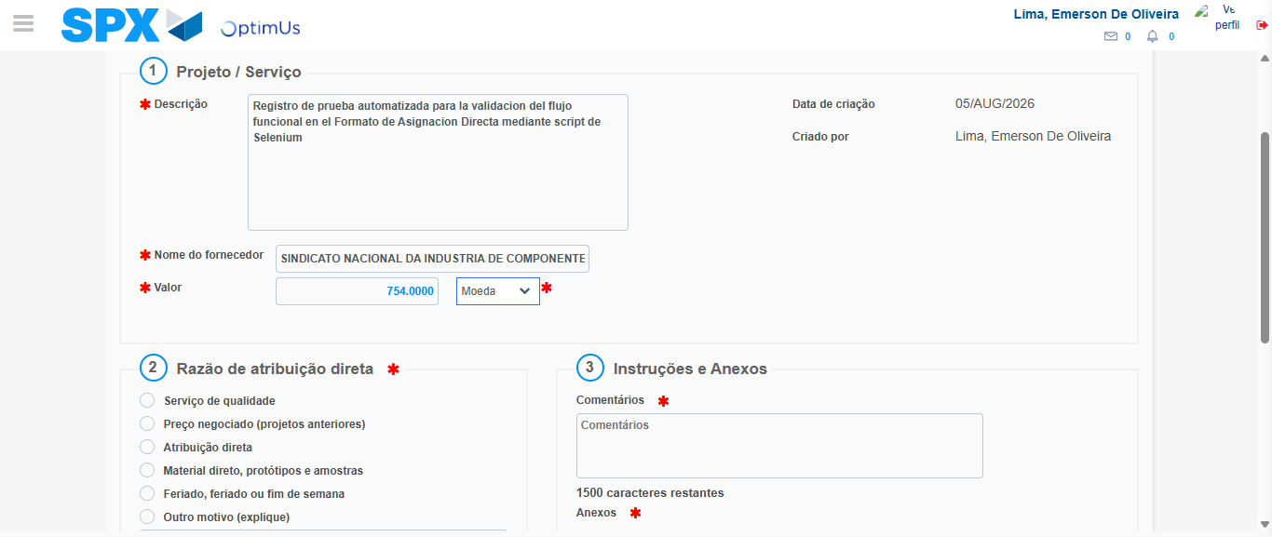Image file-name: QC_Testing-tc005_SPX_Dev5_Crear_Requisicion_Spot_Con_FAD_Tipo_Cobro_Project-1785975985701

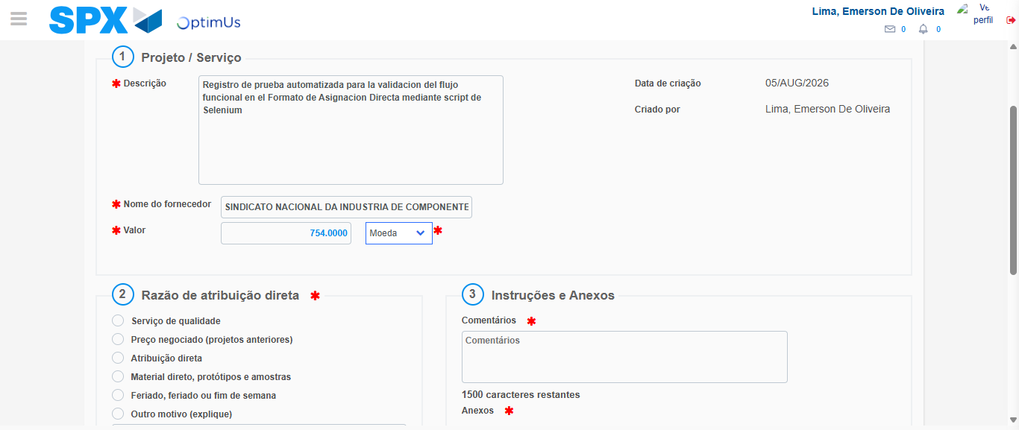Image file-name: QC_Testing-tc005_SPX_Dev5_Crear_Requisicion_Spot_Con_FAD_Tipo_Cobro_Project-1785975985901

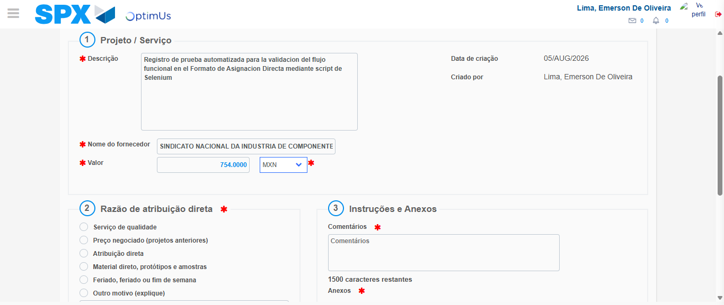Image file-name: QC_Testing-tc005_SPX_Dev5_Crear_Requisicion_Spot_Con_FAD_Tipo_Cobro_Project-1785975986230

Image file-name: QC_Testing-tc005_SPX_Dev5_Crear_Requisicion_Spot_Con_FAD_Tipo_Cobro_Project-1785975986411

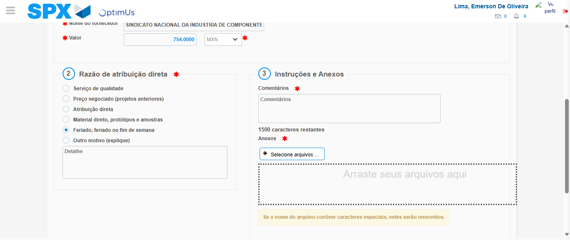Image file-name: QC_Testing-tc005_SPX_Dev5_Crear_Requisicion_Spot_Con_FAD_Tipo_Cobro_Project-1785975987262

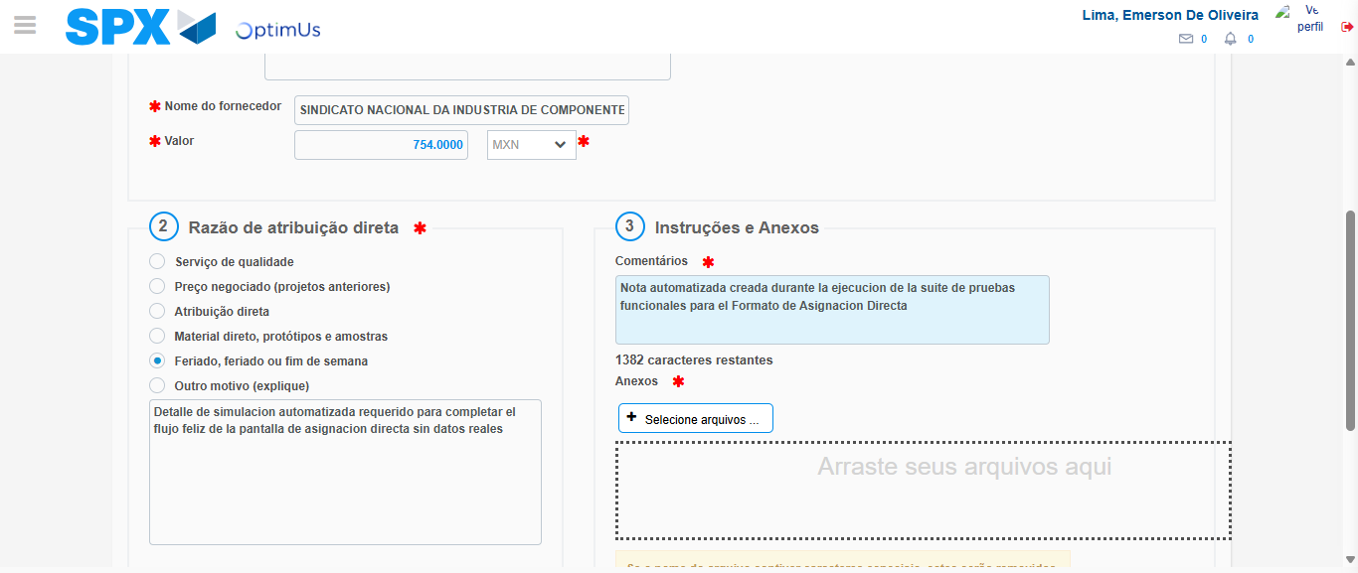Image file-name: QC_Testing-tc005_SPX_Dev5_Crear_Requisicion_Spot_Con_FAD_Tipo_Cobro_Project-1785975998304

Image file-name: QC_Testing-tc005_SPX_Dev5_Crear_Requisicion_Spot_Con_FAD_Tipo_Cobro_Project-1785975999083

Step 4 - Data Capture Spot Buy Requisition: Data captured correctly
Image file-name: QC_Testing-tc005_SPX_Dev5_Crear_Requisicion_Spot_Con_FAD_Tipo_Cobro_Project-1785975972672

Image file-name: QC_Testing-tc005_SPX_Dev5_Crear_Requisicion_Spot_Con_FAD_Tipo_Cobro_Project-1785975972836

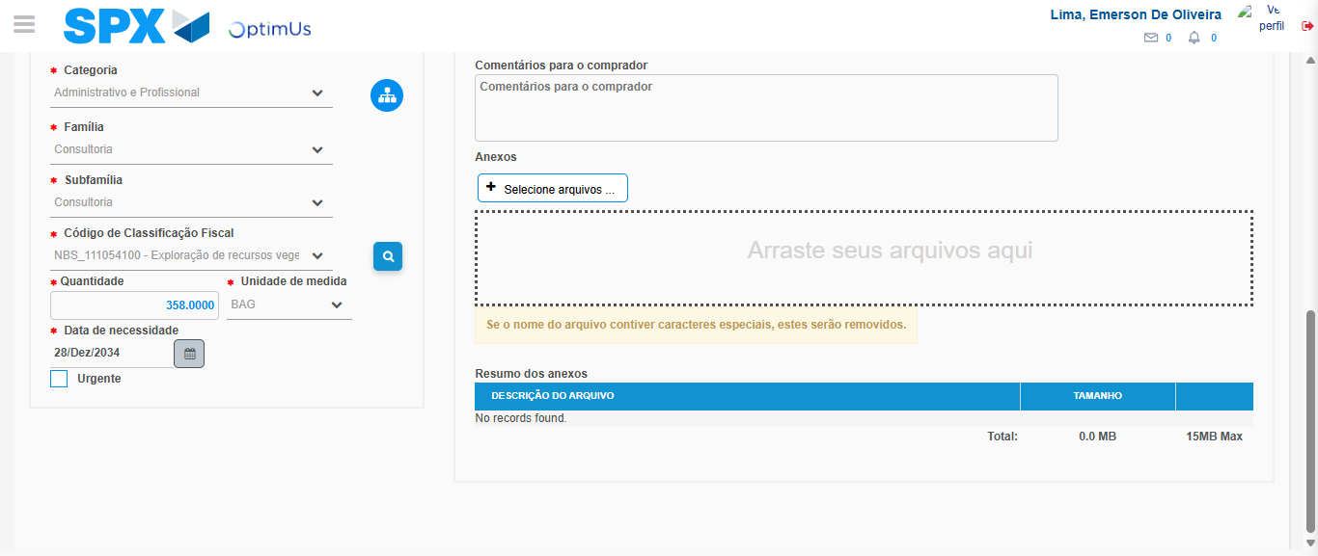Image file-name: QC_Testing-tc005_SPX_Dev5_Crear_Requisicion_Spot_Con_FAD_Tipo_Cobro_Project-1785976016288

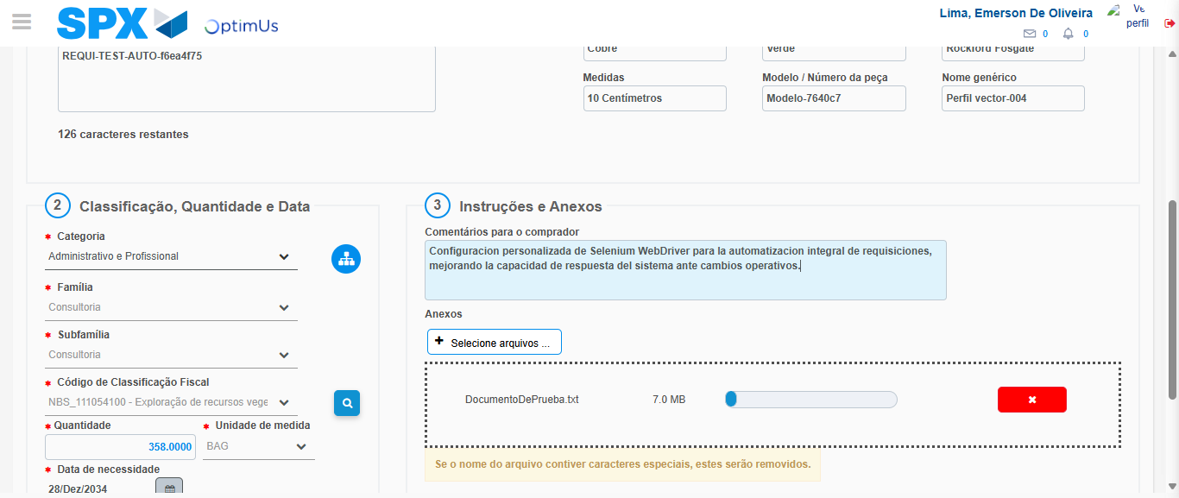Image file-name: QC_Testing-tc005_SPX_Dev5_Crear_Requisicion_Spot_Con_FAD_Tipo_Cobro_Project-1785976017039

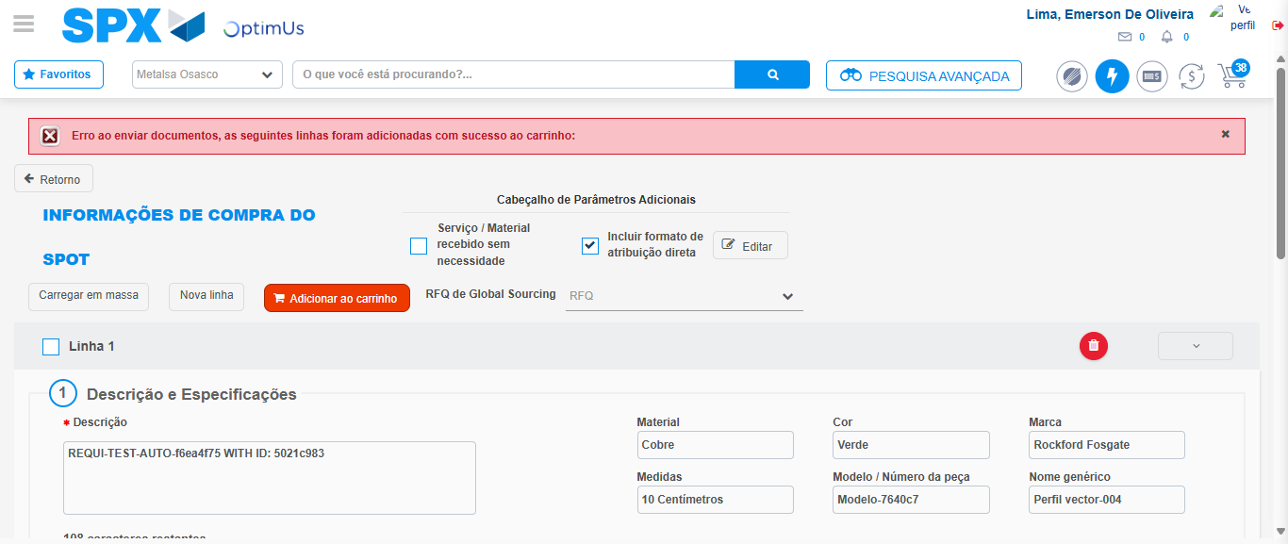Image file-name: QC_Testing-tc005_SPX_Dev5_Crear_Requisicion_Spot_Con_FAD_Tipo_Cobro_Project-1785976027127

Step 8 - Return to Main Page SPX : Return to Main Page SPX
Image file-name: QC_Testing-tc005_SPX_Dev5_Crear_Requisicion_Spot_Con_FAD_Tipo_Cobro_Project-1785975964889

Image file-name: QC_Testing-tc005_SPX_Dev5_Crear_Requisicion_Spot_Con_FAD_Tipo_Cobro_Project-1785975967428

Image file-name: QC_Testing-tc005_SPX_Dev5_Crear_Requisicion_Spot_Con_FAD_Tipo_Cobro_Project-1785975972444

Image file-name: QC_Testing-tc005_SPX_Dev5_Crear_Requisicion_Spot_Con_FAD_Tipo_Cobro_Project-1785976029388

Image file-name: QC_Testing-tc005_SPX_Dev5_Crear_Requisicion_Spot_Con_FAD_Tipo_Cobro_Project-1785976029568

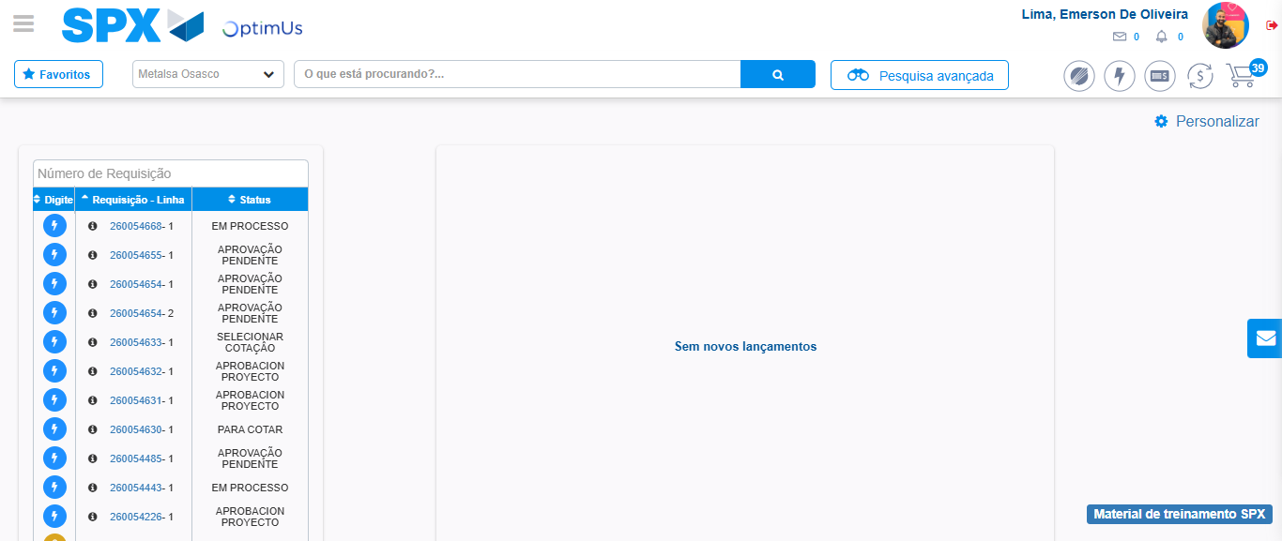Image file-name: QC_Testing-tc005_SPX_Dev5_Crear_Requisicion_Spot_Con_FAD_Tipo_Cobro_Project-1785976050540

Step 9 - Log Out : Log Out SPX
Image file-name: QC_Testing-tc005_SPX_Dev5_Crear_Requisicion_Spot_Con_FAD_Tipo_Cobro_Project-1785976050747

